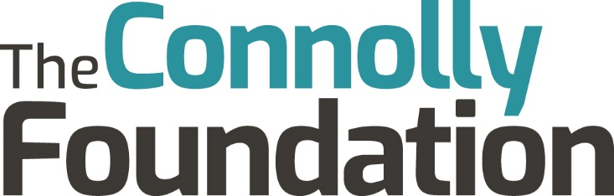

Grant Giving Policy

Charitable Objectives
We seek to make grants to improve people’s lives in Bedfordshire. Our Founder, the late Michael Connolly, wanted to improve the lives of people in Bedfordshire by giving young people the opportunity to improve their lives and by giving older people the opportunity to live their lives in comfort and dignity. We work with charities, Community Interest Companies, schools, colleges, universities and other institutions set up for the benefit of either young people or older people. We work through other institutions rather than giving grants to individuals.
We do not give grants for any of the following
- Grants to individuals. Bursaries are administered through schools and colleges.
- Support for services that are the statutory duty of the state.
- Services delivered outside the county of Bedfordshire.

Young people’s grants
Our focus is on supporting all young people to expand their horizons, take the next steps in their life and to create the best possible future for themselves and their communities.
Our grant giving for young people currently covers three categories:

Bursaries
We provide help to both University and FE College students, who have demonstrated their commitment, to meet the financial costs of further study. These are awarded through schools and College and are not awarded on an individual basis.

Aspirations, careers and choices
This includes careers (including self-employment, entrepreneurship and portfolio working), and support for experiences that inspire young people to see their future differently.

Removing barriers to learning
This includes young people who find the classroom a difficult place, and those disadvantaged by background, disabilities, illness or discrimination.
We encourage innovation and support initiatives to encourage young people to set and reach aspirational goals for themselves and their communities.
We give a lower priority to grants for capital equipment.

Older peoples’ grants
We take the view that anyone who is seen to be in the last 15% of their life can be considered old. It is recognised that this means that the age of those defined as old will vary depending on economic circumstances – for instance an individual living in an area of greater disadvantage may be experiencing the impact of old age at the age of 55 whereas an individual living in an area of high economic activity may not exoperience similar disadvantages until 75 or beyond.
We support older people by:
- Supporting befriending and other services aimed at reducing loneliness and isolation in older people
- Supporting community transport projects, especially those which help older people access other services such as health care appointments
- Supporting exercise and health promotion projects
- Supporting hospice and end of life care
- Giving grants for supporting older people to access technology, especially where this helps older people to access state benefits.
We do not support health care services or advocacy services, although we do recognise that many of the services that we do support will include advocacy. As we focus on services in Bedfordshire it is difficult for us to support research into diseases that affect older people as it is likely that the benefit will extend beyond the county.

Innovation Fund
We will set aside funds for projects where new approaches or techniques are being pioneered to improve the lives of people in a more efficient or effective way. We will be prepared to take a greater risk in outcomes for these grants on the basis that the benefits could be ground breaking.

Applications
Applications for grants can be made through our website by using the following link
How to apply - The Connolly Foundation
Applications should explain:
- The public benefit that will be delivered
- Who will benefit
- How the applicant will measure the success of the project

Successful applicants will be asked to demonstrate their financial sustainability by submitting their most recent accounts, and their commitment to the safety of their beneficiaries by submitting their safeguarding policies.
Where larger amounts or longer term commitments are requested, we will investigate the applicant organisation in more depth and expect to take a larger role in the management and monitoring of the project.

Review of policy
As the activities of the charity change, the grant giving policy will evolve to meet the needs of the community. Therefore this policy should be reviewed every year to make sure that it reflects the charity’s strategy and the needs of the people of Bedfordshire.
Last reviewed | Next review due
28th May 2026 | May 2027

